1. **create aws api gateway API called hackathon-aws-creds with lambda function hackathon_sts_token integration**

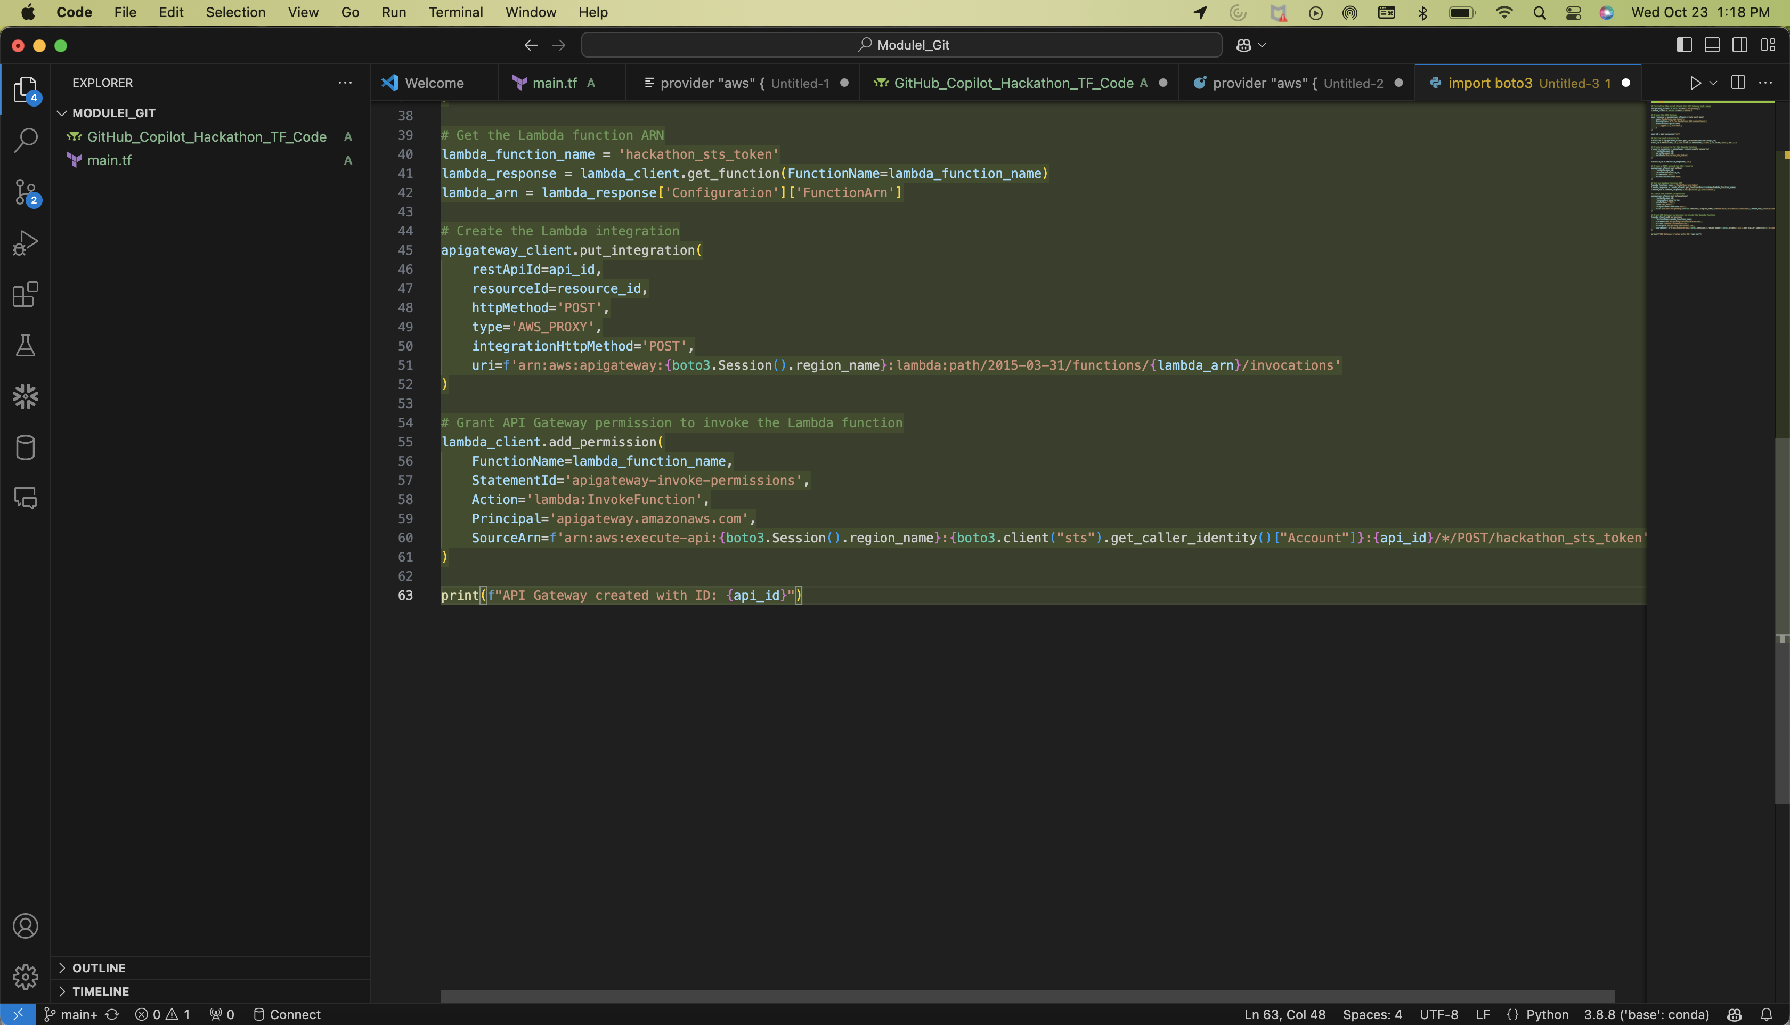

import boto3

# Initialize the boto3 client for API Gateway and Lambda

apigateway_client = boto3.client('apigateway')

lambda_client = boto3.client('lambda')

# Create the API Gateway

api_response = apigateway_client.create_rest_api(

name='hackathon-aws-creds',

description='API for hackathon AWS credentials',

endpointConfiguration={

'types': ['REGIONAL']

}

)

api_id = api_response['id']

# Get the root resource id

resources = apigateway_client.get_resources(restApiId=api_id)

root_id = next(item['id'] for item in resources['items'] if item['path'] == '/')

# Create a resource for the Lambda function

resource_response = apigateway_client.create_resource(

restApiId=api_id,

parentId=root_id,

pathPart='hackathon_sts_token'

)

resource_id = resource_response['id']

# Create a POST method for the resource

apigateway_client.put_method(

restApiId=api_id,

resourceId=resource_id,

httpMethod='POST',

authorizationType='NONE'

)

# Get the Lambda function ARN

lambda_function_name = 'hackathon_sts_token'

lambda_response = lambda_client.get_function(FunctionName=lambda_function_name)

lambda_arn = lambda_response['Configuration']['FunctionArn']

# Create the Lambda integration

apigateway_client.put_integration(

restApiId=api_id,

resourceId=resource_id,

httpMethod='POST',

type='AWS_PROXY',

integrationHttpMethod='POST',

uri=f'arn:aws:apigateway:{boto3.Session().region_name}:lambda:path/2015-03-31/functions/{lambda_arn}/invocations'

)

# Grant API Gateway permission to invoke the Lambda function

lambda_client.add_permission(

FunctionName=lambda_function_name,

StatementId='apigateway-invoke-permissions',

Action='lambda:InvokeFunction',

Principal='apigateway.amazonaws.com',

SourceArn=f'arn:aws:execute-api:{boto3.Session().region_name}:{boto3.client("sts").get_caller_identity()["Account"]}:{api_id}/*/POST/hackathon_sts_token'

)

print(f"API Gateway created with ID: {api_id}")

1. **Create dynamodb table hackathon-user-table with provisoned capacity 2, userid and policies as columns**

import boto3

# Initialize a session using Amazon DynamoDB

dynamodb = boto3.resource('dynamodb')

# Create the DynamoDB table

table = dynamodb.create_table(

TableName='hackathon-user-table',

KeySchema=[

{

'AttributeName': 'userid',

'KeyType': 'HASH' # Partition key

}

],

AttributeDefinitions=[

{

'AttributeName': 'userid',

'AttributeType': 'S'

}

],

ProvisionedThroughput={

'ReadCapacityUnits': 2,

'WriteCapacityUnits': 2

}

)

# Wait until the table exists.

table.meta.client.get_waiter('table_exists').wait(TableName='hackathon-user-table')

print("Table created successfully.")

1. **Create S3 bucket hackathon-bucket-1 with restricted S3 bucket policy**

import boto3

# Initialize a session using Amazon S3

s3 = boto3.client('s3')

# Create a bucket

bucket_name = 'hackathon-bucket-1'

s3.create_bucket(Bucket=bucket_name)

# Define the bucket policy

bucket_policy = {

"Version": "2012-10-17",

"Statement": [

{

"Sid": "AddPerm",

"Effect": "Deny",

"Principal": "*",

"Action": "s3:*",

"Resource": f"arn:aws:s3:::{bucket_name}/*",

"Condition": {

"Bool": {

"aws:SecureTransport": "false"

}

}

}

]

}

# Convert the policy to a JSON string

bucket_policy = json.dumps(bucket_policy)

# Set the new policy on the given bucket

s3.put_bucket_policy(Bucket=bucket_name, Policy=bucket_policy)

print(f"Bucket {bucket_name} created with restricted policy.")

1. **Create IAM role hackathon-sts-system-role with permission to create IAM roles with name hackathon-* , create and attach IAM policies starting with hackathon* , sts:AssumeRole on IAM roles hackathon*, RW access on Dynamodb table hackathon-user-table**

import boto3

# Initialize a session using Amazon STS

session = boto3.Session()

iam_client = session.client('iam')

# Define the trust policy for the role

trust_policy = {

"Version": "2012-10-17",

"Statement": [

{

"Effect": "Allow",

"Principal": {

"Service": "sts.amazonaws.com"

},

"Action": "sts:AssumeRole"

}

]

}

# Define the permissions policy for the role

permissions_policy = {

"Version": "2012-10-17",

"Statement": [

{

"Effect": "Allow",

"Action": [

"iam:CreateRole",

"iam:CreatePolicy",

"iam:AttachRolePolicy",

"sts:AssumeRole",

"dynamodb:PutItem",

"dynamodb:GetItem",

"dynamodb:UpdateItem",

"dynamodb:DeleteItem"

],

"Resource": [

"arn:aws:iam::*:role/hackathon-*",

"arn:aws:iam::*:policy/hackathon*",

"arn:aws:dynamodb:*:*:table/hackathon-user-table"

]

}

]

}

# Create the IAM role

role_response = iam_client.create_role(

RoleName='hackathon-sts-system-role',

AssumeRolePolicyDocument=json.dumps(trust_policy),

Description='Role with permissions to manage hackathon resources'

)

# Attach the permissions policy to the role

policy_response = iam_client.put_role_policy(

RoleName='hackathon-sts-system-role',

PolicyName='hackathon-permissions-policy',

PolicyDocument=json.dumps(permissions_policy)

)

print("Role ARN:", role_response['Role']['Arn'])

5. Create AWS lambda function  hackathon_sts_token and attach IAM role hackathon-sts-system-role

import json

import boto3

def lambda_handler(event, context):

sts_client = boto3.client('sts')

assumed_role_object = sts_client.assume_role(

RoleArn="arn:aws:iam::123456789012:role/hackathon-sts-system-role",

RoleSessionName="AssumeRoleSession1"

)

credentials = assumed_role_object['Credentials']

return {

'statusCode': 200,

'body': json.dumps({

'AccessKeyId': credentials['AccessKeyId'],

'SecretAccessKey': credentials['SecretAccessKey'],

'SessionToken': credentials['SessionToken']

})

}

